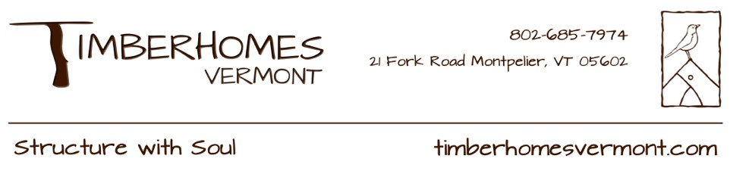

**Short-Term Site Carpenter Job Description**

**Vershire, VT**

# About TimberHomes Vermont

TimberHomes is a small, worker-owned and worker-managed design/build construction company with a focus on the beautiful craft of timber framing. We build custom-designed barns, cabins, houses, carports, pavilions, kiosks, and more! Our buildings reflect our company values, which include soulful building practice, ecological responsibility, worker quality of life, and community/client involvement. Employees participate in the day-to-day decision making involved in cooperatively managing the company and our dispersed organizational structure is designed to empower individuals to have authority over their own work.

# Position Summary

TimberHomes’ Vershire shop seeks one full-time (35-40 hours/week), short-term site carpenter to join our worker-cooperative for our build season, spring through fall. Our projects scheduled so far for the 2025 build season that this position might be asked to work on include but are not limited to: the completion of siding on a 2024 barn located in White River Junction, VT; the cutting and raising of a planed and oiled house frame in Woodstock, VT; and a 24’ x 32’ cross gabled garage with unfinished apartment above located in South Strafford, VT.

Job responsibilities include but are not limited to: timber frame raising, installation of roof boards, roofing underlayment, air sealing, siding, floors, insulation, doors, windows, stairs, and other finish details. Some additional shop carpentry may occur such as preparing trim, window casings, stairs, etc.; pre-raising and project mobilization tasks; and other projects as assigned. Prior experience with site carpentry skills is strongly preferred, and TimberHomes will train individuals on TimberHomes’ specific construction details and standards and/or skills that are unfamiliar to them.

This position is a short-term, temporary position. Timberhomes is also currently hiring for a full-time, long-term shop/site carpenter. All applications go to the same place, so just specify which one you are interested in upon submission. Some of our long-term carpenters have started with us as short-term workers and in December of 2025, TimberHomes will reassess its need for additional long-term carpenters.

**Desired Skills and Competencies:**

* willingness and ability to commute to site
* general knowledge of the carpentry trade and building materials
* ease with reading/following plans and accurately measuring/laying out timbers
* ability to operate the full complement of carpentry tools comfortably and safely, including traditional hand tools
* capacity to work with the flow of labor and materials in a busy job setting
* ability to lift and carry 50 lbs
* comfort working and operating tools at heights
* experience with heavy equipment (tractors, loaders, trailers, etc.) and securing heavy loads is helpful, but not required
* a strong work ethic, attention to detail, excellent problem-solving skills, a positive attitude, and aptitude for both independent and team-oriented work

# Ideal Experience and Our Company Culture

The ideal candidate would have shop and site carpentry experience with some timber framing knowledge. However, a background in other trades or other relevant hands-on work could be a sufficient substitute.

Our Timber Gnomes (as we call ourselves) are tight knit; we try to maintain a steady flow of baked goods and some of us talk about our feelings at work. We value diversity and inclusion, and welcome applications from anyone and everyone as long as they have some carpentry and/or trades experience. We're proud to have many women and queer-identified carpenters working for TimberHomes.

Our wage system is transparent to all employees. Feel free to inquire about our starting wages and the many other benefits of working at TimberHomes.

To apply, please send an interest letter (Why TimberHomes? Why this position?) and a brief resume or list of experience to Carly (carly@timberhomesllc.com). We will review applications on a rolling basis until the job is filled.