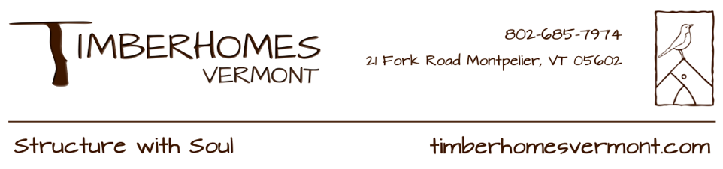

**Shop & Site Carpenter Job Description**

**Vershire, VT**

**About TimberHomes Vermont**

TimberHomes is a small, worker-owned and worker-managed design/build construction company with a focus on the beautiful craft of timber framing. We build custom-designed barns, cabins, houses, carports, pavilions, kiosks, and more! Our buildings reflect our company values, which include soulful building practice, ecological responsibility, worker quality of life, and community/client involvement. Employees participate in the day-to-day decision making involved in cooperatively managing the company and our dispersed organizational structure is designed to empower individuals to have authority over their own work.   
  
  
**Position Summary**TimberHomes’ Vershire shop seeks one full-time, long-term experienced shop and site carpenter to join our worker-cooperative with a start time of around April 1st. A TimberHomes carpenter's primary responsibilities in the shop include timber framing, general carpentry (preparing trim, doors, window casings, stairs, etc.), pre-raising and project mobilization tasks, and other projects as assigned. Site carpenter responsibilities include but are not limited to timber frame raisings and installation of roofs, siding, floors, insulation, doors, windows, stairs, and other finish details. Substantial site carpentry often happens May-December. Prior experience with shop and site carpentry skills is strongly preferred, and TimberHomes will train individuals on TimberHomes’ specific construction details and standards and/or skills that are unfamiliar to them.  
  
These positions encompass a “path to ownership,” as all full-time employees have the option to become owners following four years of employment and 6000 hours worked. Ownership comes with financial benefits as well as responsibility for collaboratively making long-term decisions about the company. Ideal candidates would have a genuine interest in working within our cooperative setting and could see themselves actively participating in our shared decision-making processes and taking on additional roles and tasks within the company.

**Desired Skills and Competencies:**

* general knowledge of the carpentry trade and building materials
* ease with reading/following plans and accurately measuring/laying out timbers
* ability to comfortably and safely operate the full complement of carpentry tools, including traditional hand tools
* capacity to manage the flow of labor and materials in a busy job setting
* familiarity with electronic media/software and willingness to learn SketchUp
* ability to lift and carry 50lbs
* comfort working and operating tools at heights
* willingness and ability to drive to job sites
* experience with heavy equipment (tractors, loaders, trailers, telehandlers, etc.) and securing heavy loads is helpful, but not required
* a strong work ethic, attention to detail, excellent problem-solving skills, a positive attitude, and aptitude for both independent and team-oriented work

**Ideal Experience and Our Company Culture**  
The ideal candidate would have shop and/or site carpentry experience with some timber framing knowledge. However, a background in other trades or other relevant hands-on work could be a sufficient substitute. The candidate would be interested in living and working in the Vershire area for an extended period, ideally already with roots in the local community.   
  
Our Timber Gnomes (as we call ourselves) are tight knit; we try to maintain a steady flow of snacks and treats and some of us talk about our feelings at work. We value diversity and inclusion, and welcome applications from anyone and everyone as long as they have some carpentry and/or trades experience. We're proud to have many women and queer-identified carpenters working for TimberHomes.   
  
Our wage system is transparent to all employees. Feel free to inquire about our starting wages and the many other benefits of working at TimberHomes.

To apply, please send an interest letter (Why TimberHomes? Why this position?) and a brief resume or list of experience to Carly (carly@timberhomesllc.com). We will review applications on a rolling basis until the job is filled.